1. **Title of the project**

Predicting power output based on weather conditions on wind Turbine

**1.1-Introduction**

Introduction should contain information about python and AI

* 1. **Objectives of Research**
* This project is aimed at developing a Predicting power output based on weather conditions on wind turbine, demonstrates a promising capability of reducing the uncertainties in the power curve model.
* Accurate and reliable wind power predictions are necessary to optimize the integration of wind power into existing electrical systems.

**1.3 Problem Statement**

The rapid development of wind energy in many countries and the associated high uncertainties and fluctuations in power generation present a big challenge for both wind power generators and electric grids.

This power prediction is useful for the Energy Traders & Decision makers. They can get a conclusion following things by the power output:

1. At which location they can plant these wind mills.
2. How much supply of power can be given to a city near by the plants.
3. Systematic validations regarding both wind speed and power output were carried out against the observations for the target wind farm, which show that the hybrid power forecasting system presented in this paper can be an effective and practical tool for short-term predictions of wind speed and power output in various areas.

1. **Review of literature**

The rapid development of wind energy in many countries and the associated high uncertainties and fluctuations in power generation present a big challenge for both wind power generators and electric grids.

1. **Data Collection**

In Wind Turbines, Scada Systems measure and save data's like wind speed, wind direction, generated power etc. for 10 minutes intervals.

The data's in the file are:

* Date/Time (for 10 minutes intervals)
* LV ActivePower (kW): The power generated by the turbine for that moment
* Wind Speed (m/s): The wind speed at the hub height of the turbine (the wind speed that turbine use for electricity generation)
* Theoretical_Power_Curve (KWh): The theoretical power values that the turbine generates with that wind speed which is given by the turbine manufacturer
* Wind Direction (°): The wind direction at the hub height of the turbine (wind turbines turn to this direction automaticly)

**4. Methodology**

**4.1 Exploratory Data Analysis**

**4.1.1 Figues and Tables**

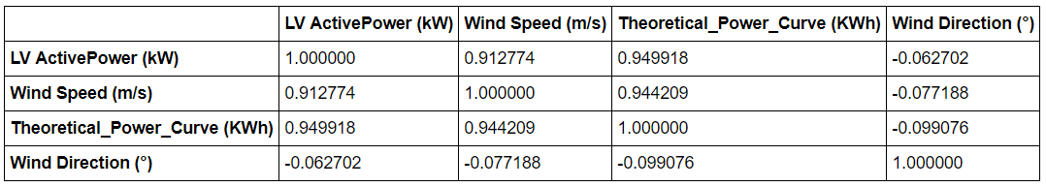

The above is the correlation table. As we can observe that the magnitude is high between the Theoretical Power which is the out put & the LV Active Power. The second high is with the Wind speed. And there is a very less between the Wind direction. Hence only the LV Power and Wind speed are considered as inputs.

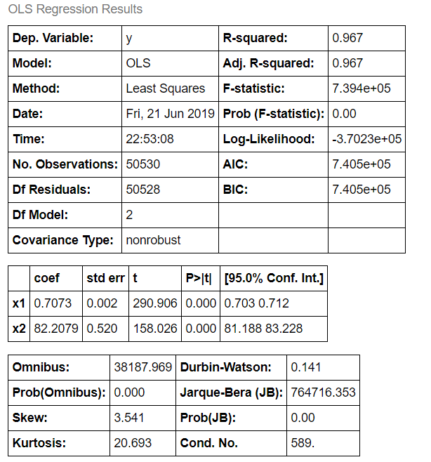

* R-squared - explain the amount of varience of the model. As for the good model it should be high, we got 0.967.
* Adjusted Rsquare - Goodness of fit(). We got it as 0.967 which is almost high. Hence this is a good model.
* p>[t] - Probability Test. Since it is < 5% Alpha (0.05) then REJECT Null Hypothesis. Since, there is a significant relation between the attributes.
  1. **Data Modelling**

The data set is of Supervised Machine Learning which means there is a target variable which is Theoretical Power and two predicting variables. As the target variable i.e., Theoretical_Power_Curve (KWh) is a continuous (numerical) attribute and that too all of with different values. Hence, Regression model has to be used to get the accuracy of the model. Also more than one input we use Polynomial regression Model to predict the out put.

**5. Conclusion**

* This power prediction is useful for the Energy Traders & Decision makers. They can get to a conclusion of following things by the power output:

1. At which location they can plant these wind mills.
2. How much LV Active power can be given to a city near by the plants.
3. Systematic validations regarding both wind speed and power output were carried out against the observations for the target wind farm, which show that the hybrid power forecasting system presented can be an effective and practical tool for short-term predictions of wind speed and power output in various areas.